

Thesis Project Proposal

Feature Selection for Brain Computer Interface using Genetic Algorithm

Timothy Mahoney (42360366)

Supervised by: Assoc. Prof. Marcus Gallagher

November 5th, 2018

letter

acknowledgments

Marcus

Brendan and Nick

Abstract

# Table of Contents

Table of Contents 1

1 Introduction 2

1.1 Aim and Scope 2

1.2 Proposal Layout 3

2 Background 4

2.1 Electroencephalography 4

2.1.1 Frequency Bands 5

2.1.2 Artefacts 5

2.2 Brain Computer Interface 5

2.2.1 Feature Extraction 6

2.3 Feature Selection 6

2.4 Computational Optimisation 7

2.4.1 Genetic Algorithm 7

2.4.2 Particle Swarm Optimisation 8

2.5 Classification Algorithms 9

2.5.1 Support Vector Machine 9

2.5.2 Random Forest 9

2.5.3 Artificial Neural Network 9

3 Previous Studies 10

3.1 Automated Feature Selection for Brain Computer Interfaces 2003 10

3.2 Feature Selection for Brain Computer Interfaces 2009 10

3.3 Particle Swarm Optimisation for a Brain Computer Interface 11

3.4 EEG Classification with Advanced Feature Extraction and Machine Learning 11

4 Risk analysis 12

4.1 Breach of Copyright 12

4.2 Data Loss 12

4.3 Underestimation of Time Requirement 13

5 Project Plan 14

5.1 Milestone 1: Preparation of the Dataset 14

5.2 Milestone 2: Extract Features 14

5.3 Milestone 3: Feature Selection Using PSO 15

5.4 Milestone 4: Feature Selection Using GA 15

5.5 Milestone 5: Classification 16

6 Conclusion 17

7 Bibliography 18

List of figures

List of tables

List of Acronyms

BCI

EEG

EOG

EMG

ECG

SVM

ANN artificial neural net

Artefact

Motor Movement (MM)

Motor Imagery (MI)

ERD ERS

ICA

AAR

SL

GA PGA

GBE

Preface

The report clearly defines and explains the background of a Master of Engineering Science thesis project to be conducted by the author at the University of Queensland. A thorough exploration of background material is covered in Section 2, followed by an investigation into previous similar studies in Section 3. A risk analysis is displayed in Section 4 and Section 5 covers the project plan, including milestones, assessment dates and a timeline.

# Introduction

Advances in computational power and machine learning techniques has enthused global interest in the development Brain Computer Interfacing (BCI) technology. With applications ranging from motor and sensory prosthetics, to communication and even connection to the internet of things, BCI advancement has the potential to provide significant benefits to society. Recently, Facebook has begun development of a BCI to enable typing via thought [1], engineers at Johns Hopkins University have created a BCI capable of controlling an upper limb prosthesis [1], even Elon Musk’s latest venture is in BCI technology with his startup company *Neuralink* [2].

Currently however, effectively classifying neural data in an online and non-invasive scenario is no trivial problem. Features relevant to neural events include temporal patterns in a variety of frequency bandwidths across many spatially separated electrodes. Due to the high spatial resolution and frequency bandwidth of non-invasive electroencephalographic (EEG) signals, one hurdle slowing BCI development is determining what data is useful and what can be ignored. Selecting an appropriate subset of features from such a large set of candidates could reduce the computational complexity and hardware requirements of such a system, thereby improving the systems feasibility.

## Aims and Scope

This project examines various methods of feature selection to produce a heuristically optimal subset of features using the natural selection based optimization technique Genetic Algorithm (GA), for the purpose of motor-imagery event classification, from non-invasive neural data (EEG). The specific aims can be summarised in three points:

1. Use Genetic Algorithm to establish a heuristically optimal subset of features from the full EEG feature set.
2. The subset should both significantly reduce the number of features *and* result in low classification error
3. The data sampling and processing methods should simulate an online BCI system such that it should be: automated, computationally efficient and robust to slow sampling.

Specifically, after filtering and artefact removal, we extract features consisting of temporal data spanning standard EEG frequency bands from 64-channel EEG recordings. The extracted features are passed to the Genetic Algorithm selector which is implemented as a wrapper, such that the metric used to evaluate a feature set’s fitness is classification error with a Support Vector Machine (SVM).

DIAGRAM: 64 CHANNEL DATA > FILTERING and ARTEFACT REMOVAL > FEATURE EXTRACTION > GA <> SVM

The dataset being used was created in 2004 by the BCI2000 instrumentation system and contributed to the PhysioNet database [3] [4]. The dataset contains over 1500 one- and two-minute EEG recordings from 109 participants. The system used 64 channel EEG with a sampling rate of 160 Hz. It consisted of 14 experimental runs including two baseline recordings (eyes open, then closed) and three repeats of four tasks. The datasets being considered for this project are of Task 2: the subject *imagines* closing their left or right fists (motor imagery, MI) for a period in response to visual cues. We pose the task as a binary classification problem, with labels corresponding to left (L) or right (R) MI events. The aim of the BCI for this project is to classify these events using the EEG recordings.

MATLAB will be the primary software package being used to import, sample, optimise and classify the data. This is because the author is familiar with the software package and there is a substantial pool of supporting documentation available for correctly implementing most, if not all, of the processes involved with this project.

It should be noted that there are assumptions being made in this project. Previous studies have investigated the effects of user specific parameter selection under the motivation that EEG responses can be dependent on the subject [7]. Due to the nature of the dataset, implementing the BCI in this way may produce less meaningful results as the number of experimental runs per person is too small. Lastly, the focus topic for this project is the optimisation methods being implemented, hence the classification algorithms are simply used to evaluate the performance of the features selected and will not be investigated in detail.

# Background

BCI systems are the culmination of knowledge across fields spanning biology, neuroscience, electrical and biomedical signal processing, and machine learning to name a few. The following section covers, in detail, the large amount of background knowledge required for this project due to the multidisciplinary nature of BCI technology. All background information is referenced accordingly should the reader be interested in further reading.

## Electroencephalography

Electroencephalography (EEG) is the recording of action potentials originating from the brain. It is most often used in the study of brain functionality or the diagnoses of neurological disorders [8]. EEG signals are sampled using several small electrodes placed on the scalp, which can detect minute potential differences non-invasively on the surface of the skin [8]. Through proper filtering and signal processing techniques, the summation of electrical activity from local neurons can be isolated and displayed allowing professionals to examine neural activity pertaining to each electrode [8].

The exact placement of the electrodes is a generally subject to the standardised International 10-20 System, whereby the distance between left-right and front-back electrodes is either 10% or 20% of the total skull distance [9]. The electrodes are labelled according to the area of the brain, or lobe, that they’re reading from. These are pre-frontal (Fp), frontal (F), temporal (T), parietal (P), occipital (O) and central (C) as seen in Figure 1 [8] [9]. The number of electrodes in total varies, systems can sample anywhere from 1 to 256 EEG signals in parallel [8].

Figure 1 (left) Standard EEG labelling of each lobe. (right) Examples of EEG positioning and recordings [8]

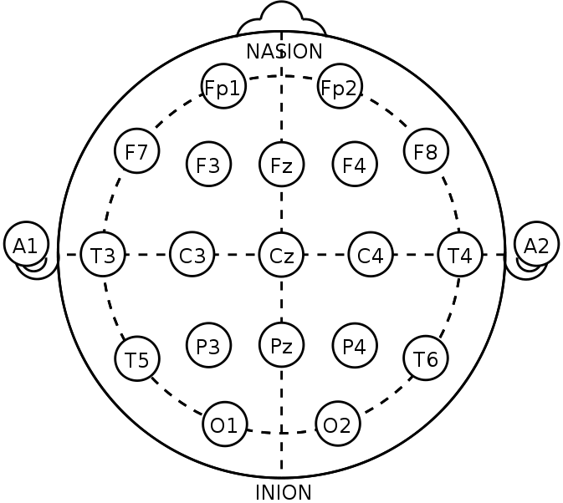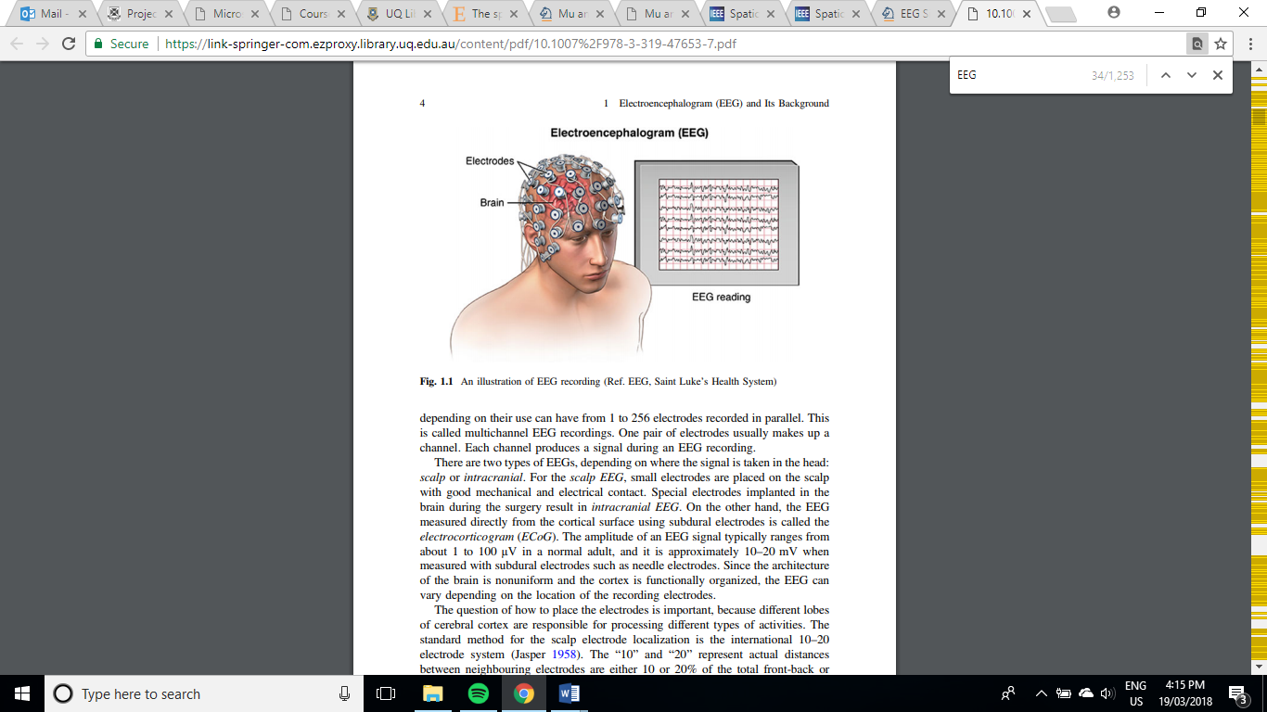

## Cortical Homunculus

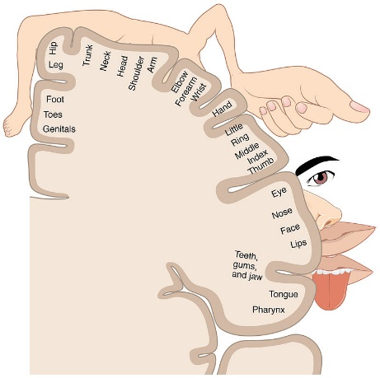Neural sensory and motor function are generally thought to be confined to certain spatial locations within the brain. A cortical homunculus is an illustration describing this spatial separation as observed from the brains surface along a coronal cross section at either the sensory or motor cortex. Considering the homunculus depicted in Figure X, we can see the tissue associated with hand control is a relatively large portion approximately half way down the cortex. While we do aim to find an appropriate and small feature set using primarily GA, for the purposes of this project we can perform some preliminary reduction of the feature space by neglecting the peripheral channels of the EEG as we can, with confidence, say that these channels are unlikely to relate to MI events associated with hand movement.

## 2.1.2 Frequency Bands

|  |  |  |  |  |  |  |
| --- | --- | --- | --- | --- | --- | --- |
| Band | Delta | Theta | Mu | Alpha | Beta | Gamma |
| Frequency (Hz) | 0.5 - 4 | 4 – 7 | 7-12 | 11-15 | 15-31 | >31 |

The frequency components of EEG are considered some of the most important criteria for interpreting brain function [8]. The bandwidth of these components is commonly defined in Table X.

The presence or absence of each component is generally associated with a particular type of brain function or state [8]. For instance, the three bands which are commonly associated with sensory-motor function are alpha, beta and mu waves, and are hence the three frequency bands being used for feature extraction in this project.

## 2.1.3 Event Related De/Synchronisation

There is evidence to suggest that in addition to the amplitude of each bandwidth indicating a neurological event, temporal patterns referred to as event related de/synchronisation (ERD, ERS) between particular bands may correlate to the mind processing information [5] [6]. ERS occurs when there is an observable increase in neural activity due to the synchronisation of neurons firing action potentials at a given frequency band. Likewise, ERD is the phenomena of de-synchronised neurons cancelling each other out, thereby reducing the observable electrical potential of a given frequency band. ERS and ERD events shown to relate to sensory-motor activity last over a period of seconds. In order to consider this information in the feature set for this project, we include features extracted from previous samples as inputs into our classifier.

## 2.1.4 Artefacts

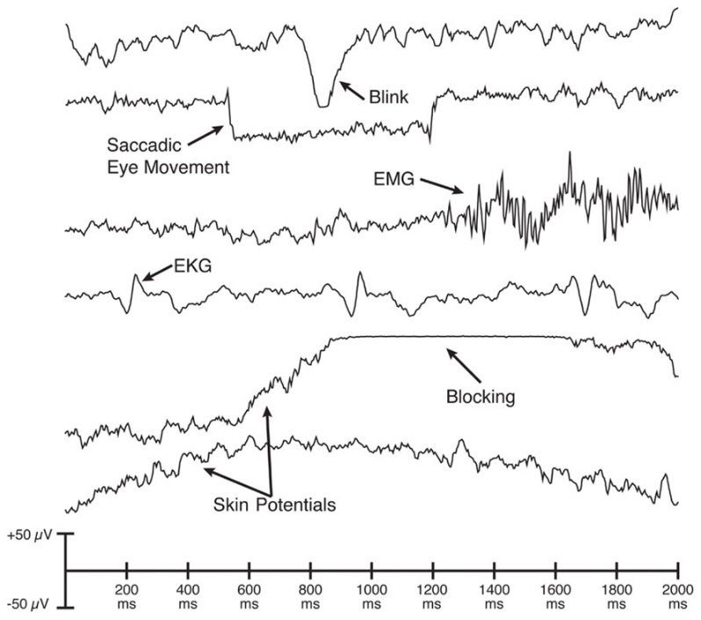Signals included in EEG recordings that do not originate from neural potentials are referred to as artefacts. They can be introduced from other physiological events such electromyographic signals (EMG) from muscles, electrooculographic signals (EOG) from eye movements or even electrocardiographic signals (ECG) from the heart. They can also exist as noise from poor electrode contact or 50/60Hz mains coupling. EEG signals can easily be corrupted by artefacts as their amplitude is in the range of 10-100μV, hence filtering techniques have been thoroughly explored in previous studies to establish clean signals for professional examination or further processing [8].

Three commonly used artefact removal methods include:

1. Epoch removal – simply manually remove any epoch samples corrupted with artefacts
2. Manual artefact removal – manually remove components likely to be artefacts before reconstructing the signals
3. Automated artefact removal (AAR) – implement automated classification and removal of artefacts

As this project aims to produce a solution which is capable of online classification, implementing AAR is the ideal method of artefact removal. Artefacts are commonly classified by first separating the n-channel EEG into some k components (k≤n), and then considering features of these components such as their temporal pattern, frequency response and spatial distribution. Components are isolated using Independent Component Analysis (ICA).

ICA is often likened to isolating voices in a crowd. Given a number of spatially separated microphones, ICA is able to isolate specific voices (or components) by combining information from each. In the case of EEG data, we have 64 channels all sampling a symphony of neural information and artefacts. Components isolated from this data may be attributed to either one of these groups, if we can identify which we can remove artefact components before reconstructing the channels. The automated ICA implementation for this project will be discussed in more detail in the Methods section.

## Brain Computer Interface

A brain-computer interface (BCI) aims to establish a pathway between neuropsychological signals and an external device [10]. One potential goal of such an interface is to provide a substitute method of communicating or controlling extremities for people with neuromuscular impairments [8] [10]. The ability to classify mental imagination events would allow patients to regain some degree of freedom whether it be through wheelchair or neuroprosthesis control, or communication. With proper training a person could repurpose their neural pathways for any number of applications to improve quality of life. However, for such BCI systems to be considered a useful alternative control method they need to achieve critical performance requirements for robustness, consistency and safety [10].

Mason and Birch described a general framework for BCI systems as a way of standardising ideas and terms for these devices to aid with their development and comparison [11]. The framework consists of 6 steps [11] [8]:

**Brain activity measurement** - the sampling of the raw EEG data

**Pre-processing** – digital to analogue conversion, initial filtering and artefact removal

**Feature extraction** – retrieve meaningful features of the EEG data which can discriminate between mental states being used to control the system

**Classification** – employ some algorithm which can classify mental states based on the extracted features.

**Translation into a command** – relate the result of classification with a response in the target device.

**Feedback** – sensory feedback to the user not only allows them to know that the device is working, but also helps train their brain to use it.

The proposed project will focus on the area of feature extraction but will include elements of pre-processing and classification methods.

Commonly used mental responses for controlling a BCI are motor imagery (MI), where the subject imagines moving without performing the movement, and motor movement (MM), which is the brains response to an actual motor movement being made. Of these two tasks, this project will only consider MI as this medium is inherently more suited to applications such as limb replacement.

## Feature Extraction

One of the most critical elements of a functional BCI is effective feature extraction. As discussed in sections 2.1.1, 2.1.2 and 2.1.3, the features being extracted span frequency, space and time in order to best utilise known phenomena observable in the EEG data relating to MI events. Prior to input into feature selection, the data undergoes only one more process known as Surface Laplacian (SL).

SL is a transformation commonly used to improve spatial resolution of EEG data [13]. When EEG data is sampled, it is measured as a potential difference between each channel and some reference electrode. This means there is often redundant information common to neighbouring electrodes due to their close proximity. SL is a matrix multiplication which effectively decouples the channels from the reference electrode, transforming the recordings into comparative measurements between neighbours. There are several SL techniques, each with varying complexity as described by Carvalhaes and de Barros [13], however the method used in this project only considers the simple Finite Difference Method as described in the reference and presented in Appendix A. This method makes the assumptions that the scalp surface is locally flat and that electrodes are equidistant [13]. These assumptions are considered reasonable for the purposes of this Thesis. SL is the final step of feature extraction before employing feature selection.

## Feature Selection

Consider the case where a 128 channel EEG was divided into its 5 frequency bands and the mean of each band for the previous 5 samples was taken as the feature set, resulting in a 3200 long feature set. A feature vector this large introduces several problems in the classification stage, such as [12]:

1. Over complicating the classification model
2. Long training time
3. Slow real time BCI performance
4. Increased risk of overfitting
5. Curse of dimensionality – small ratio of data to number of features

Feature selection attempts to counter these problems by selecting a subset of features without incurring much loss of information [12]. The selection process follows the premise that certain features may correlate with each other (termed: *redundancy*), whereas others may have little to do with classification so including them within the feature vector results in no information gain (*irrelevance*). Feature selection algorithms are essentially a search problem across candidate feature subsets, for some set which is at least heuristically optimal concerning some evaluation score. Score metrics depend on the specific algorithm being applied, the three types are: filter, wrapper and embedded [13]. Filter algorithms select the feature subset independent of the prediction method, whereas wrappers assess the subset using the predictor and embedded methods optimise the subset in the process of training the predictor [13]. This project initially considers the use of a filter feature selector before expanding into methods involving wrappers.

## Computational Optimisation

Computational optimisation uses algorithms to minimise or maximise an objective function. In the case of EEG feature selection, the objective function would be the metrics we chose to optimise for (e.g. minimise redundancy, maximise relevance) over the space of feature subsets. If the space of subsets includes every combination of the feature vector proposed earlier (3200 features), there exists over 10963 combinations of features. Brute force search methods over this space are not computationally feasible and as such optimisation problems involving large spaces over many dimensions have led to the creation of novel search algorithms to find *good enough* optimal solutions, these are referred to as *heuristic* algorithms. These methods aim to computationally balance *exploration* and *exploitation* of the search space. Exploration is the wide spread search of the space, often at random, in order to avoid focussing on what could only be local optima, whereas exploitation attempts to converge on the ideal local solution based on information the algorithm has already discovered. This project implements one such heuristic search method base on the evolutionary phenomena: natural selection. The method is Genetic Algorithm (GA).

## Genetic Algorithm

As is the case with many optimisation methods, GA is an algorithm designed to mimic the principals of a naturally occurring system. The method takes the process of evolution, such that the genetic code of the parents is inherited by the child, and simulates a ‘survival of the fittest’ scenario over a series of generations [14]. With respect to this project, the genetic code of the parents/child would be a combination of EEG features and the measure of ‘fitness’ could be the metrics of redundancy and relevance for that particular combination. The method starts with randomly generated parents in the search space. The next generation is computed with a combination of three *genetic operators* [14]:

**Reproduction operator:** poor solutions are neglected, whereas fit solutions are passed down. The number of candidates is preserved by including more children with strong performance to replace the those lost. The resulting candidates are now part of what is referred to as the *mating pool*. It can be seen that the reproduction operator does not result in any new solutions, they are formed in the remaining two operators. Passing on the best candidates to the next generation directly is a method of preserving the best solution, these best candidates are referred to as *elite children*.

**Crossover Operator:** there are a few variations of this operator, but generally two candidates (the parents) from the mating pool are chosen randomly and a subsection of their genetic structure is switched to form children. This operation supplies new candidates with genes that have been previously shown to perform well in the reproduction stage, in the hope that they may perform better than their parents.

**Mutation Operator:** the remaining codes are now subject to mutation, where there exists a small probability that one or more of their genes may be altered. This introduces exploration into the algorithm, allowing it to traverse previously unseen areas of the search space in pursuit of better optima.

The scores of each candidate are computed after these operations in order to inform the algorithm how best to manipulate the next generation. Bit strings pertaining to high scores are carried through to next generations, whereas poor solutions are not. New generations are computed continuously until some stopping criteria is met, for example a certain number of generations or a high score threshold. The process is described quite well by Deb, K. who uses the example of minimising materials used to produce a cylinder of set volume as a function of diameter and height [14]. It is worth noting that this algorithm in no way encourages a significant reduction in the number of features selected, only that a high scoring solution be found. Creatively altering or adding to the method is required to achieve this, which is further discussed in the Methods section.

## Classification Algorithms

Classifiers are used in this project for AAR and MI event classification. The scope largely consists of investigation into optimisation techniques however, as such exploring and tuning of machine learning aspects of the project are relatively brief. The classifiers used in the project include an Artificial Neural Network (ANN) and a Support Vector Machine (SVM). These methods were chosen as they have been used previously with EEG classification [16] [17] [18] and MATLAB documentation on their implementation is extensive.

## Artificial Neural Network

An ANN mimics the principals of neural pathways in the brain. A single neuron takes weighted inputs from one or more neurons in a previous layer, where it can then signal other neurons in subsequent layers. The weights between the neurons are updated as learning progresses, tuning the network to accept data features as inputs and predict its class based off supervised learning from a training set. A wide variety of network topologies exist, however this project will only be considering simple feedforward networks with a small number of layers. Hyperparameters consist of the number of layers, the number of neurons in each layer, the training function, the performance metric and the stopping criteria.

## Support Vector Machine

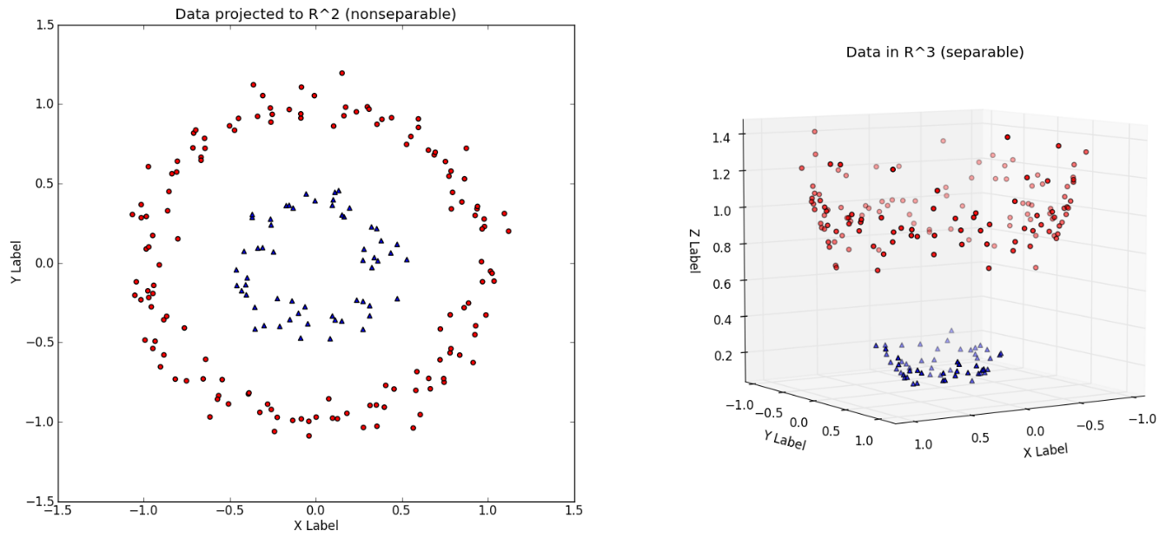Support Vector Machines are simple discriminant classifiers which construct an optimal hyperplane in the sample space between classes from a training set. The resulting hyperplane is then the discriminant used to classify new data points. Usually, the best hyperplane is taken as the one that maximises the separation of the classes. In cases where the data is not linearly separable, SVM can still work quite well if the data is extended to a higher number of dimensions via some kernel function. Kernel functions are used to map the features to some higher dimension where they are seen as separable and hence can be classified by the SVM, an example of this is shown in Figure X.

SVM parameters include the kernel function and the soft margin penalty scalar.

## Previous Related Study

*EEG Classification with Advanced Feature Extraction and Machine Learning* by Alomari et al. uses the same dataset proposed for use with this project [20] [3] [4]. They propose a system which focuses on feature extraction, rather than selection. The features include Energy, Power and Mean metrics for ERD and ERS events of the beta and alpha bands, as well as Movement Related Cortical Potentials (MRCP. The feature set is evaluated using an ANN and SVM. The results show high classification accuracy: 97.1% using SVM and 86.5 using ANN. This paper sets a benchmark for this project to aim for and may provide insight into the importance of feature extraction vs. feature selection. Comparison may also highlight limitations in the approaches of both papers in spite of the same dataset.

# Methods

The following section contains the methods used and decisions made during the project period. Any results displayed in this section are done so to validate the project before moving to subsequent methods, or to justify an alteration in the approach. Final results pertaining to the feature selection methods employed are held out and displayed in the Results section.

## Initial Filtering

Before anything else, we filter the data. We apply a bandpass filter between 0.5-80Hz to eliminate any baseline drift and high frequency noise. We also apply a 60Hz notch filter to reduce mains coupling (USA frequency). The frequency responses are shown in Figure X. Having performed basic filtering, the data is ready for artefact removal.

– filter frequency responses 😊

## Independent Component Analysis

ICA is applied to the data using the FastICA algorithm [21]. First the data must be centered and whitened. Centering the data implies setting the mean of each channel across all samples to zero:

$$x_{ij}←x_{ij}-\frac{1}{M}\sum_{j'}{x_{ij'}}$$

Whitening the data involves transforming the centered data into an uncorrelated set with variance equal to one. This can be achieved through eigenvalue decomposition of the covariance matrix of the centered data, such that:

$$X←ED^{-\frac{1}{2}}E^{T}X$$

Where *E* is the matrix of eigen vectors and *D* is the diagonal matrix of eigenvalues.

With our nicely centered and whitened data, we can now apply the FastICA algorithm as shown in Figure X.

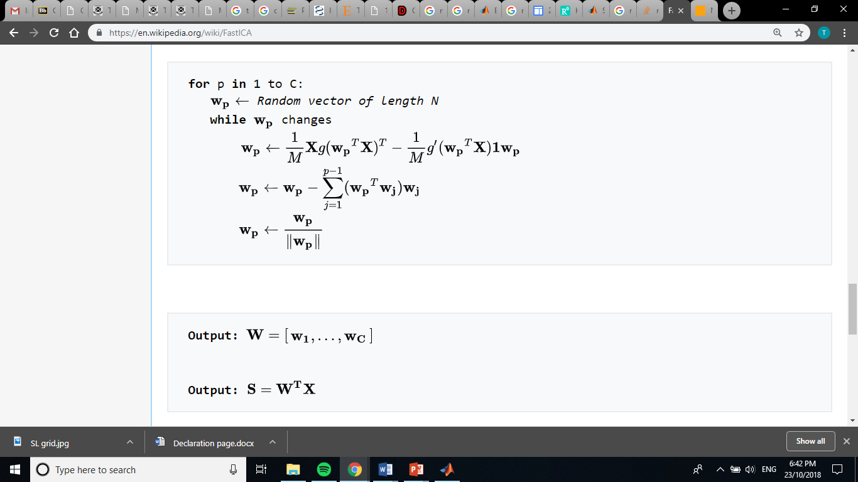

Where:

$g\left(u\right)=\tanh\left(u\right)and g^{'}\left(u\right)=1-\tanh^{2}(u)$

*C* is the number of components

*M* is the number of samples

*N* is the number of features

*W* is the component weight vector or unmixing matrix

*S* is the component matrix

This algorithm is quite simple to implement in MATLAB. The resulting *S* matrix gives us our component set. The next step is to extract features from these components to pass to a classifier. We can speculate what approach to take for feature extraction by examining what experts look for when manually labelling artefact components.

Two PhD candidates studying psychology and neuroscience at the University of Queensland, Brendan Keane and Nick Bland, have extensive experience analysing EEG data and identifying artefact components with ICA. Both were consulted to help identify signature attributes of an artefact component for the purposes of this project. Attributes indicating an artefact were summarised as:

1. Components which are spatially condensed to one, or few sparse channels (electrode shift)
2. Components with a frequency response showing peaks at high frequencies (>80Hz) or at USA mains frequency (60Hz)
3. Components with activity localised at peripheral electrodes (EMG) or frontal electrodes (EOG, blinking or eye movement)
4. Components spread over a strong majority if not all of the channels (noise)

In the absence of all of these observations, a component was labelled as *not* an artefact. Using these guidelines, 3000 components were manually labelled to be used as training data for a classifier to implement AAR. Examples of these components are displayed in Figure X.

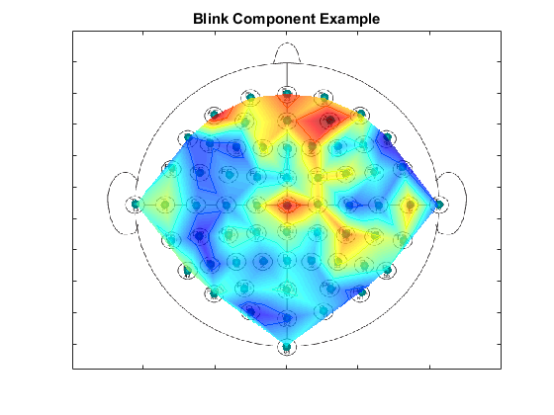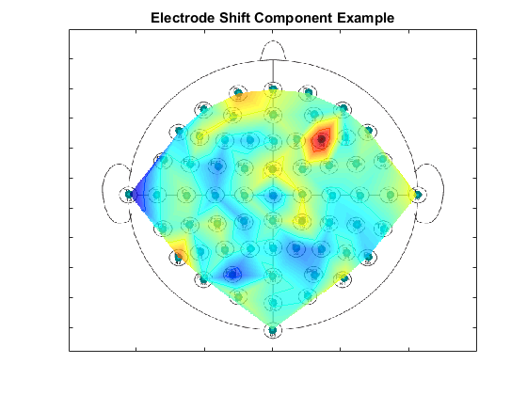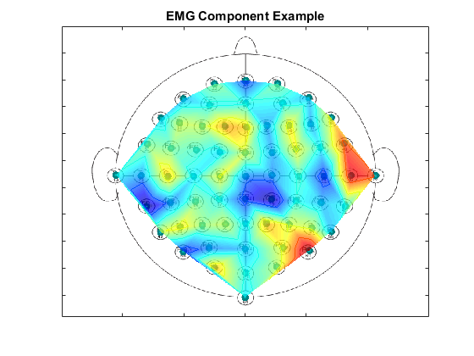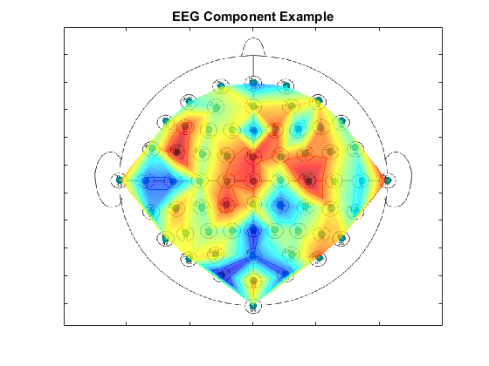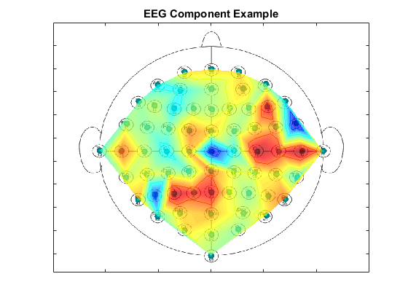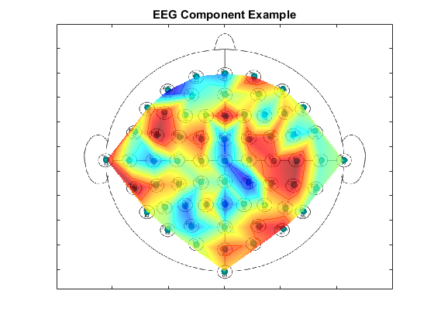

Features were extracted from the components to provide the classifier with the tools to establish similar guidelines. The features are listed in Table X.

|  |  |
| --- | --- |
| Feature | Reasoning |
| Spatial mean of all channels | These features are tailored to inform the classifier of spatially observable artefacts such as those in described by guidelines I, III and IV. The classifier should learn that the amplitude of these features, and variations in comparative amplitudes of some these features can indicate that a component is or is not likely to be an artefact. |
| Spatial mean of peripheral channels |
| Spatial mean of central channels |
| Spatial mean of front channels |
| Spatial Variance |
| Spatial Kurtosis |
| Spatial Skew |
| Frequency response mean 0-80Hz | Features concerning the frequency response are aimed at arming the classifier with knowledge to identify components with high frequency or mains coupling noise, as described by guideline II. |
| Frequency response mean 59-61Hz |
| Frequency response mean >80Hz |

The classifier implemented at the center of the AAR algorithm was an ANN.

## Artificial Neural Network



Neural Net, performance

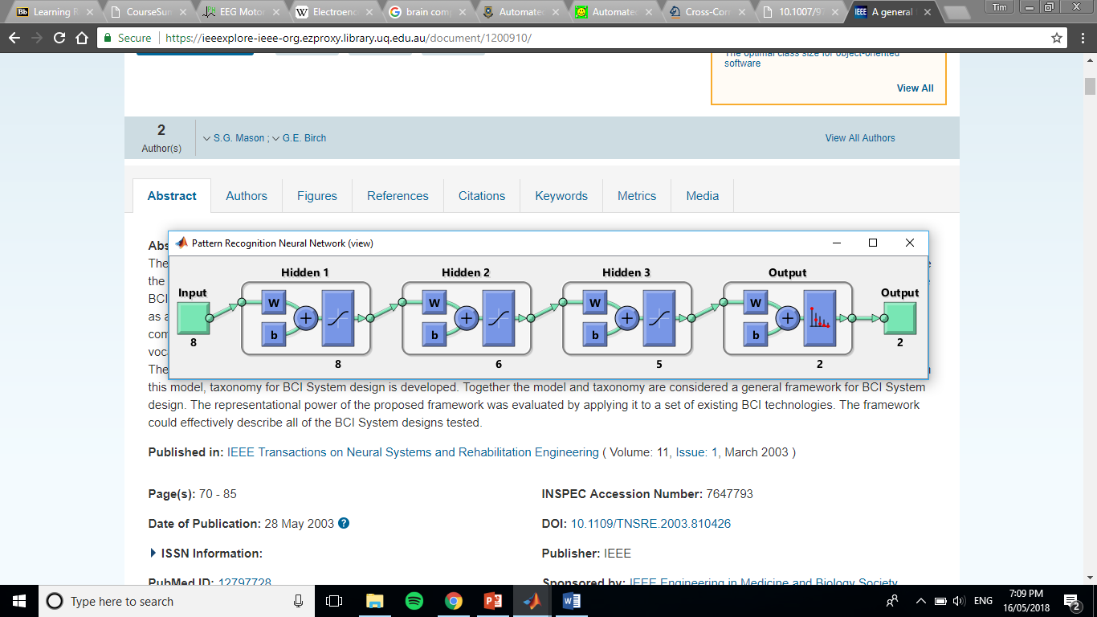





AAR pathway

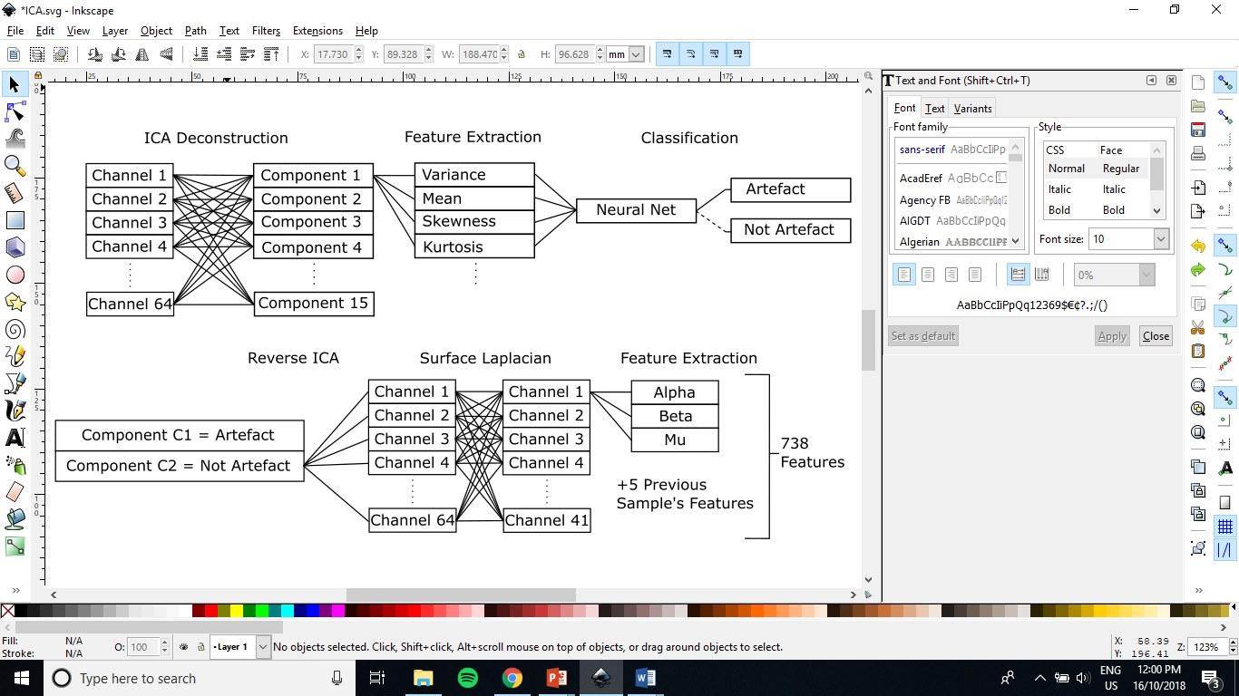

Surface Laplacian

Feature Extraction – include data segmentation, include leaving out test data

Talk about filter method with correlation

**Talk about the 4: GBE, GA, PGA, GA with GBE**

Feature selection can be modelled as a binary optimisation problem such that for any feature set $θ$:

$$θ=\left\{θ_{1},θ_{2}…θ_{n}\right\} :θ_{i}\left\{\begin{aligned}0,do not include the feature \\ 1, include the feature\end{aligned}\right.$$

Genetic Algorithm attempts to optimise a binary string given some fitness metric.

Four methods are implemented as *wrapper* feature selectors:

1. Greedy Backward Elimination
2. Genetic Algorithm
3. Penalised Genetic Algorithm
4. Genetic Algorithm with Greedy Backward Elimination

**GBE**

**Pseudo Code:**

1. Start with full feature set
2. Compute fitness of new *candidate* sets given the removal of a single feature. That is, given a current set with *n* included features, there are *n* *candidates* each excluding a different feature.
3. Next set is the set from *candidates* with the best computed fitness
4. Repeat from 2 until no features remain
5. Select the feature set which best balances fitness and number of included features

**GA**

The algorithm is applied as follows:

1. Eight candidate sets are sampled at random from the feature space to create the *candidate* pool.
2. Evaluate *candidate* pool scores.
3. Automatically include the two highest scoring candidates (elite children) in the new *candidate* pool
4. Create a *mating* pool which includes two copies of the highest scoring candidate and one of each of the next two highest scoring candidates.
5. Select six sets of two different parents from the *mating* pool at random and perform uniform crossover to produce the remaining six candidates for the *candidate* pool.
6. Apply mutation with a probability of 0.01 to every candidate except for the best.
7. Repeat from step 2 until reaching a stopping criterion of 1000 generations.

**PGA**

The performance metric used to evaluate the fitness of any candidate set $θ$ where:

$$θ=\left\{θ_{1},θ_{2}…θ_{n}\right\} : θ_{i}∈[0,1]$$

is given by the following error function:

$$error\left(θ\right)=CE\left(θ\right)+R\sum_{i=0}^{n}{[θ_{i}=1]}$$

*R* coefficient presents a trade off.

**GA with GBE**

First perform GA as usual until reaching stopping criterion.

The resulting set is the starting set for Greedy Backward Elimination

An appropriate set is then selected to include benefits from the high accuracy starting set and low feature inclusion of backward elimination

SVM – tuning

Tune box constraint and kernelfunction in nested loop

Results

Discussion

Compare the 4

Why did this happen?

Compare with previous study

Why did this happen?

# Risk analysis

Discuss how successful risk mitigation was.

This risk analysis will briefly outline the three risks involved with this project, the level of risk and actions that will be taken to minimize this risk. The risk level will be assessed against the following risk matrix:

|  |  |  |  |  |  |
| --- | --- | --- | --- | --- | --- |
|  | Severity | | | | |
| Likelihood |  | Negligible | Marginal | Critical | Catastrophic |
| Rare | Low | Low | Moderate | High |
| Unlikely | Low | Low | Moderate | Extreme |
| Possible | Low | Moderate | High | Extreme |
| Likely | Moderate | High | High | Extreme |
| Certain | High | High | Extreme | Extreme |

## Breach of Copyright

Copyright laws could be breached by including datasets and results from other studies in this project.

**Likelihood:** Rare

**Severity:** Marginal

**Risk level:** Low

**Mitigations:** All ideas and data used within this report which are not owned by the author will be referenced correctly in accordance with the University of Queensland referencing and plagiarism policy as well as per request by the original owner/s. In addition, datasets will only be collected from reputable sources.

## Data Loss

Unforeseen circumstances such as damage to or loss of the authors computer, data or other records could lead to loss of project progress. As the project progresses, the severity of this risk increases to a critical level.

**Likelihood:** Unlikely

**Severity:** Critical

**Risk level:** Moderate

**Mitigations:** All data and electronic records will be committed regularly to a git repository dedicated to this thesis project. This includes but is not limited to: any MATLAB script, function files or data sets, electronic notes and assessment items. Care will be taken to minimise risk of malware being downloaded. Computers being used to work on the project will not be left unattended while thesis material is able to be accessed.

## Underestimation of Time Requirement

This project includes many steps which require careful implementation and validation before advancing to the next stage, as discussed in Section 5. Incorrect implementation or underestimation of the time required to complete anyone of these stages could lead to limitations in the project due to time constraints.

**Likelihood:** Possible

**Severity:** Critical

**Risk level:** High

**Mitigations:** A well defined project plan has been outlined in the following section which includes milestones designed to motivate completion of the thesis within a manageable timeframe. This plan has been designed to expect delays and provide adequate time to overcome obstacles. In addition, regular correspondence with the thesis supervisor Prof. Gallegher or one of his tutors/associates has been agreed upon to verify progress and provide guidance if required.

# Project Plan

Compare original plan to actual

Discuss changes in the plan ie. Filter to wrapper, classifiers, PSO

Further research

# Conclusion

This proposal has clearly outlined the motivations, scope and aims of this project. Considerate background research was conducted to establish a solid understanding of the concepts involved across the disciplines of biology, engineering and computer science. Investigations into previous studies indicated that this particular focus on a filter type feature selector using PSO and GA for EEG MI/MM classification has not been conducted before to the authors knowledge. However, outcomes from similar studies provide confidence in this projects achievability as well as supplying a benchmark to compare results with. Potential risks to the project have been considered and steps put in place to mitigate them, and a detailed project plan has been implemented to ensure satisfactory progress. To conclude, this project is designed to explore useful techniques within the field of BCI development with the hope that further technological advances could lead to a viable alternative device control mechanism.

# Bibliography

|  |  |
| --- | --- |
| [1] | "Brain-Computer Interfaces," JHU Neuroengineering & Biomedical Instrumentation Lab, 2008. [Online]. Available: http://neuroengineering.bme.jhu.edu/ecog.htm. [Accessed 22 March 2018]. |
| [2] | "Neuralink," Neuralink Corp, 2018. [Online]. Available: https://www.neuralink.com/. [Accessed 22 March 2018]. |
| [3] | A. L. G. L. H. J. I. P. M. R. M. J. M. G. P. C.-K. S. H. Goldberger AL, "EEG Motor Movement / Imagery Dataset, PhysioBank, PhysioToolkit, and PhysioNet: Components of a New Research Resource for Complex Physiologic Signals. Circulation 101(23):e215-e220," 13 June 2000. [Online]. Available: https://www.physionet.org/pn4/eegmmidb/. [Accessed March 2018]. |
| [4] | G. M. D. H. T. B. N. W. J. Schalk, "BCI2000: a general-purpose brain-computer interface (BCI) system.," *IEEE Trans Biomed Eng,* vol. 51, no. 6, pp. 1034-1043, 2004. |
| [5] | Y. Kim, J. Ryu, K. K. Kim, C. C. Took, D. P. Mandic and C. Park, "Motor Imagery Classification Using Mu and Beta Rhythms of EEG with Strong Uncorrelating Transform Based Complex Common Spatial Patterns," *Computational Intelligence and Neuroscience,* vol. Online, 2016. |
| [6] | D. McFarland, L. Minor, T. Vaughan and J. Wolpaw, "Mu and Beta Rhythm Topographies During Motor Imagery and Actual Movements," *Brain Topography,* vol. 12, no. 3, pp. 177-186, 2000. |
| [7] | M. Schroder, M. Bogdan, T. Hinterberger and N. Birbaumer, "Automated EEG feature selection for brain computer interfaces," in *Conference Proceedings. 1st International IEEE EMBS Conference on Neural Engineering 2003*, Capri Island, Italy, 2003. |
| [8] | S. Suily, Y. Li and Y. Zhang, EEG Signal Analysis and Classification: Techniques and Applications, Gewerbestrasse: Springer International Publishing, 2016. |
| [9] | V. Towle, J. Bolaños, D. Suarez, K. Tan, R. Grzeszczuk, D. Levin, R. Cakmur, S. Frank and J.-P. Spire, "The spatial location of EEG electrodes: locating the best-fitting sphere relative to cortical anatomy," *Electroencephalography and Clinical Neurophysiology,* vol. 86, no. 1, pp. 1-6, 1993. |
| [10] | A. R. Satti, D. Coyle and G. Prasad, "Spatio-spectral & temporal parameter searching using class correlation analysis and particle swarm optimization for a brain computer interface," in *IEEE International Conference on Systems, Man and Cybernetics*, 2009. |
| [11] | S. Mason and G. Birch, "A general framework for brain-computer interface design," *IEEE Transactions on Neural Systems and Rehabilitation Engineering,* vol. 11, no. 1, pp. 70-85, 2003. |
| [12] | Y. Saeys, I. Inza and P. Larrañaga, "A review of feature selection techniques in bioinformatics," *Bioinformatics,* vol. 23, no. 19, pp. 2507-2517, 2007. |
| [13] | I. Guyon and A. Elisseeff, " An Introduction to Variable and Feature Selection," *Journal of Machine Learning Research,* vol. 3, pp. 1157-1182, 2003. |
| [14] | K. Deb, "An introduction to genetic algorithms," *Sadhana,* vol. 24, no. 4-5, pp. 293-315, 1999. |
| [15] | R. Poli, J. Kennedy and T. Blackwell, "Particle Swarm Optimization," *Swarm Intelligence,* vol. 1, no. 1, pp. 33-57, 2007. |
| [16] | A. Subas and M. Gursoy, "EEG signal classification using PCA, ICA, LDA and support vector machines," *Expert Systems with Applications,* vol. 37, no. 12, pp. 8659-8666, 2010. |
| [17] | M. Bentlemsan, E. Zemouri, D. Bouchaffra, B. Yahya-Zoubir and K. Ferroudji, "Random Forest and Filter Bank Common Spatial Patterns for EEG-Based Motor Imagery Classification," in *Intelligent Systems, Modelling and Simulation*, Langkawi, Malaysia, 2014. |
| [18] | A. Subasi and E. Ercelebi, "Classification of EEG signals using neural network and logistic regression," *Computer Methods and Programs in Biomedicine,* vol. 78, no. 2, pp. 87-99, 2005. |
| [19] | I. Koprinska, "Feature Selection for Brain-Computer Interfaces," in *Proceedings of the Workshop on Advances and Issues in Biomedical Data Mining, Pacific-Asia Conference on Knowledge Discovery and Data Mining (PAKDD 2009)*, Bangkok, 2009. |
| [20] | M. Alomari, A. Samaha and K. AlKamha, "Automated Classification of L/R Hand Movement," *International Journal of Advanced Computer Science and Applications,* vol. 4, no. 6, pp. 207-212, 2013. |

Appendix

A: SL

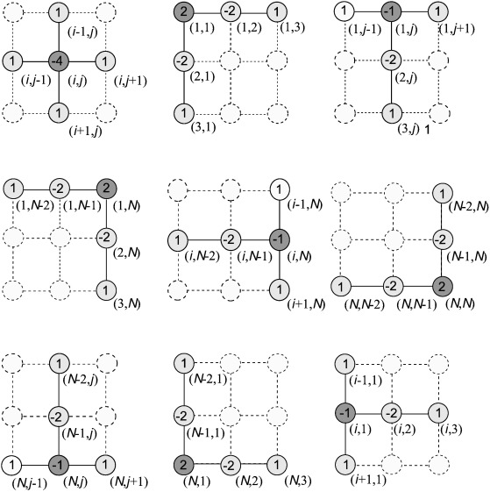

Brief description of each code function / .m file